|  |  |
| --- | --- |
| linear IPS | Year 12 Specialist  TEST 4  Weds 28 Aug 2019  TIME: 50 minutes working  Classpads allowed  No notes allowed  45 marks 8 Questions |

Name:_______________________________

Teacher: ____________________________

**Note: All part questions worth more than 2 marks require working to obtain full marks.**

Q1 ( 3, 3 & 3 = 9 marks)

Determine the following integrals using the given substitutions.

1. 
2. 
3. 

Q2 (3 marks)

Identical twins Sherry and Mary were both given the following integral to solve. 

Sherry’s solution was as follows.



While Mary’s solution was to:



Explain why the solutions differ and state which is the correct answer. Show your reasoning.

Q3 (3 & 4 = 7 marks)

Determine the following integrals showing all working.

1. 

Q3 cont-

1.  (4 marks)

(Hint- set up simultaneous equations to solve for constants on your classpad)

Q4 (4 marks)

The shaded region is rotated about the y axis. Determine the volume of the resulting solid.

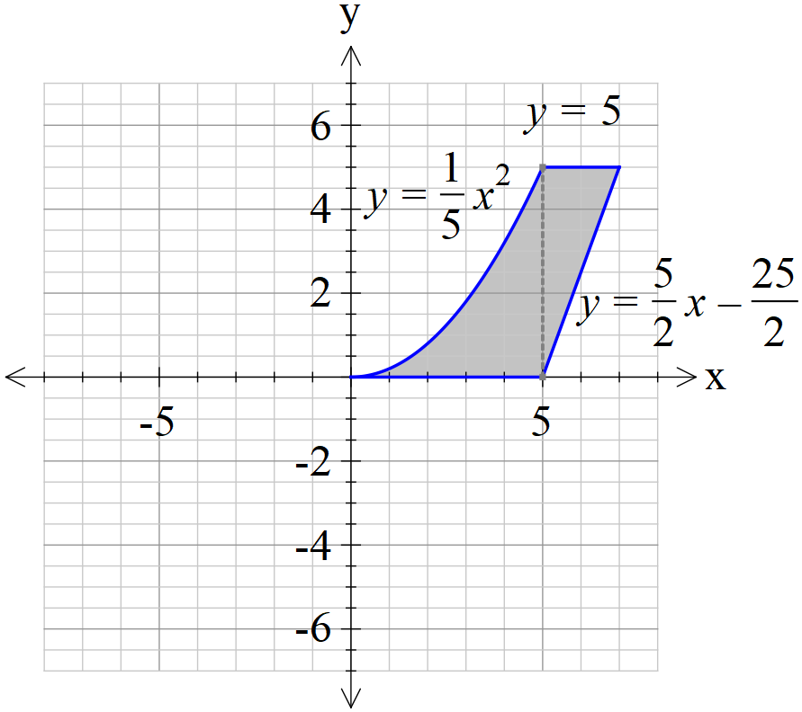

Q5 (1 & 4 = 5 marks)

The mass,  grams, of a gas produced in a factory at time  seconds can be modelled by the logistical formula  with an initial mass of 0.1 grams.

1. Determine the limiting mass as .
2. Show that  and determine the constant.

Q6 (3 & 3 = 6 marks)

1. Sketch the slope field for  on the axes below.

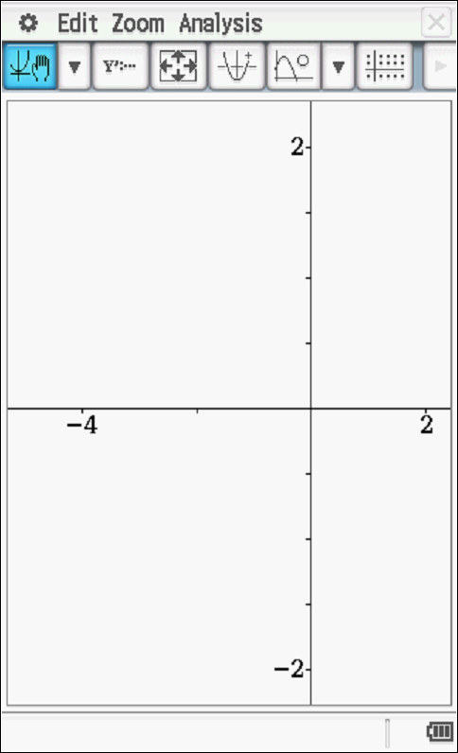

1. Given that point A (-1,1) is a known point on our solution, show this curve on the slope field above and give the equation.

Q7 (2, 3 & 2 = 7 marks)

A particle with displacement, metres from the origin at time  seconds, moves such that .

1. Show that the motion is simple harmonic.
2. Determine the first two times that the speed is exactly half of the maximum speed.
3. Determine the distance travelled in the first 3 seconds.

Q8 (4 marks)

A particle with displacement, metres from the origin at time  seconds, has an acceleration given by . The amplitude of the motion is given by  metres.

Show by integration that the speed,  metres per second, is given by .